Open the file BBT_calculator_021419.sln in Visual Studio. Two tabs should open up: **MainWindow.xaml** and **MainWindow.xaml.vb**. The first of these contains the user interface of the calculator.

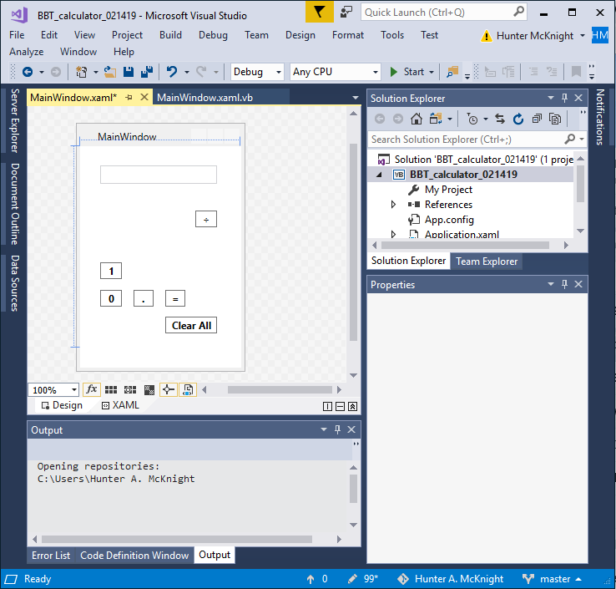

The second of these tabs contains the Visual Basic Script.

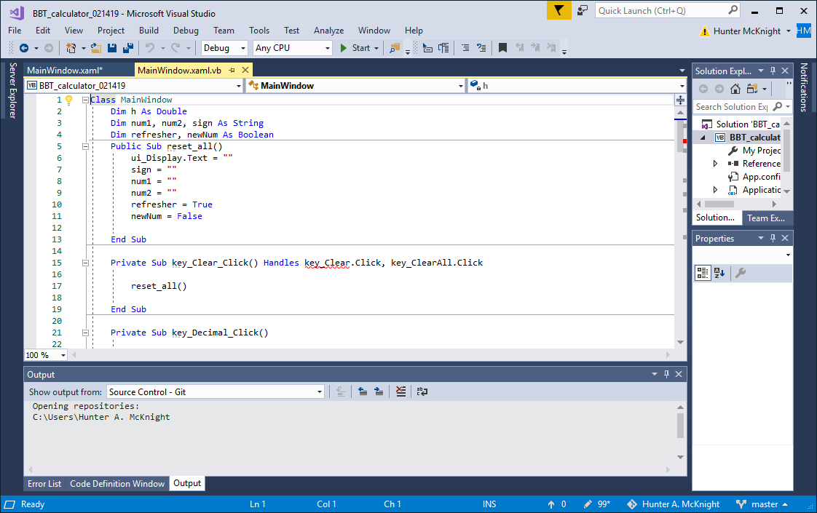

**If you are new to Visual Studio:**

Select one of the form objects in **MainWindow.xaml** and take a look at the properties window on the right. Note the name of the Object, and where the brush, layout and text menus are.

**Number Keys**

**Objective 1:** The first two numerical keys [0] and [1] are completed. Finish creating the buttons (keys) for the remaining eight digits.

**Objective 2:** Complete the code for all the remaining keys using the same exact convention as the pre-written code.

**Operation Keys**

**Objective 3:** The division key is already completed. Finish creating the button keys for multiplication, addition and subtraction.

**Objective 4:** Complete the code for these remaining operation keys using similar convention as the code for the division key.

**Optional Exercises**

1. Create another operation button key, this time for the power/exponent operation. Use the symbol “ **^** ” (shift + 6) as the label symbol for the button, and place it in the empty space to the left of the [Clear All] button. Name this button “opp_pow” and code it using the same convention as for the other operations already created within the Evaluate() function. Test out this button in runtime with some known examples. For example, when completed, the click sequence **[2], [^], [1], [0], [=]** should give you **1024** within the **ui_display** field. Also, the click sequence **[3], [^], [9], [=]** should yield **19683** in the **ui_display** field. Try some other examples as well.
2. Give some new aesthetic life to this plain black & white calculator by coloring each of the buttons and other parts of the interface using the tools in Brush and Text sections of the the properties window.